5-3 Project One Submission: Virtual Systems and Networking Concept Brief
Andree Salvo
Southern New Hampshire University
CYB 220
Instructor: Wesley Buchan
2025
- Using Virtual Systems
- Configure group policy settings to meet project specifications as identified in the InfoSec Project One Activity. Provide screenshots from the local group policy editor dialog box as evidence of each change.

- Set the Interactive logon: Message text for users attempting to log on prompt to “Warning: You are about to do something that is not authorized.”
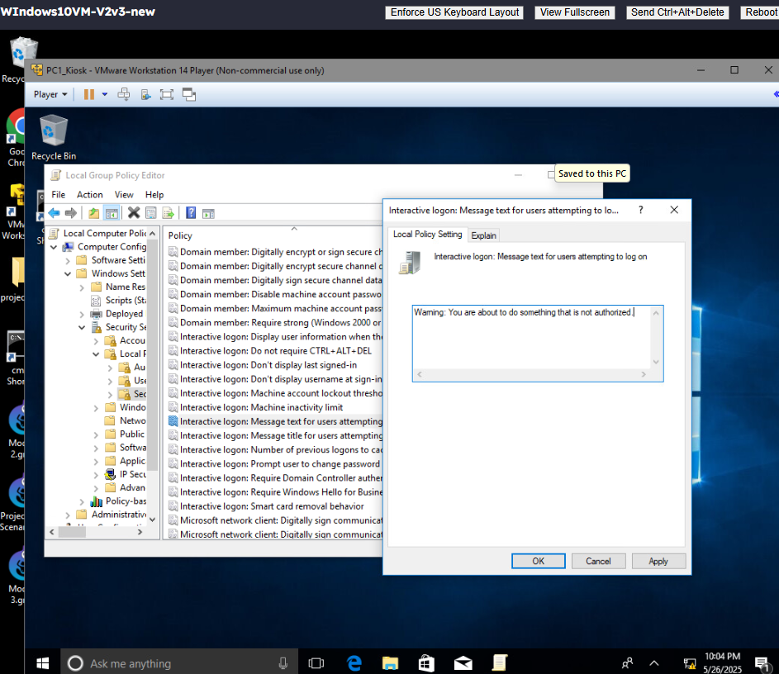

- Change local password policy setting. | - Change the minimum password length to 8.
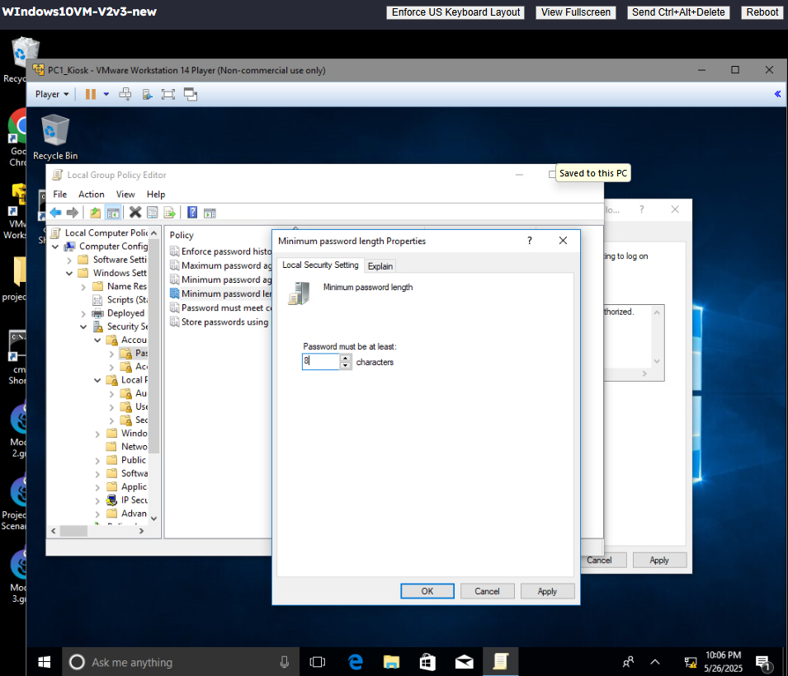

- Change desktop background user rights assignment (disable non-admin change capability). | - Set Prevent changing desktop background to disabled. Add the comment “You are not authorized to change this setting” to the comment box.
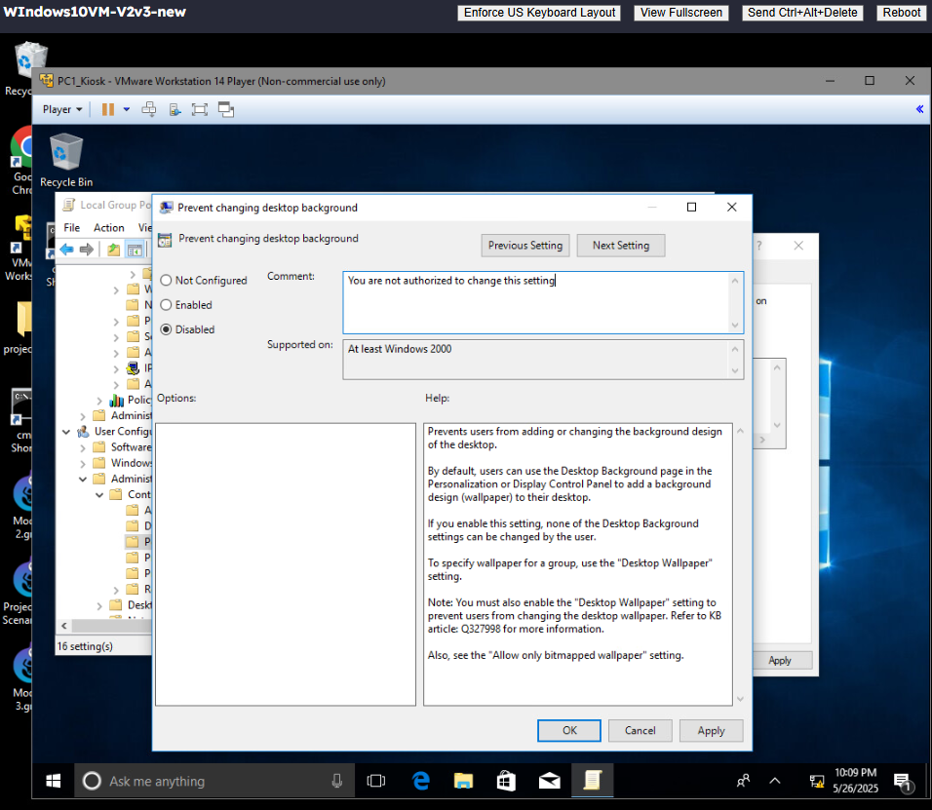

- Configure local audit policy setting. | - Set Audit logon events to enabled.
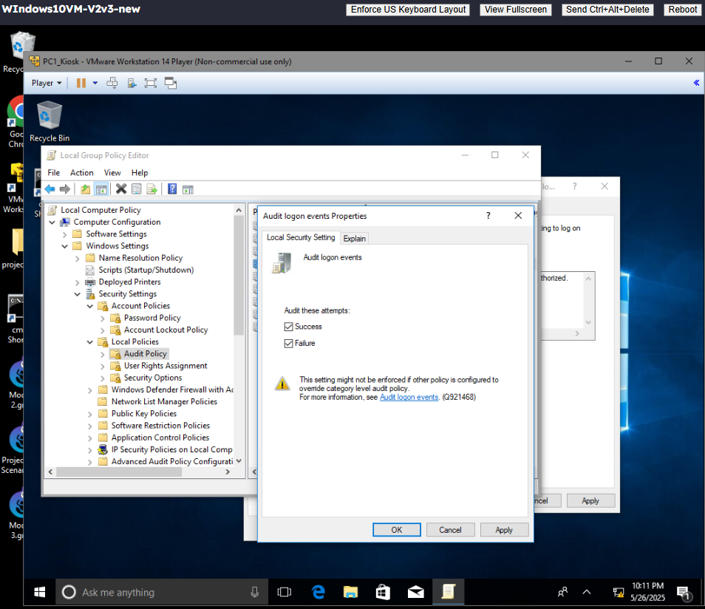

- Configure default logon banner (warning that requires direct affirmation to continue). | - Set Force a specific default lock screen and logon image to enabled, and provide a path to the lock screen image of C:\windows\SNHULogo.jpg.
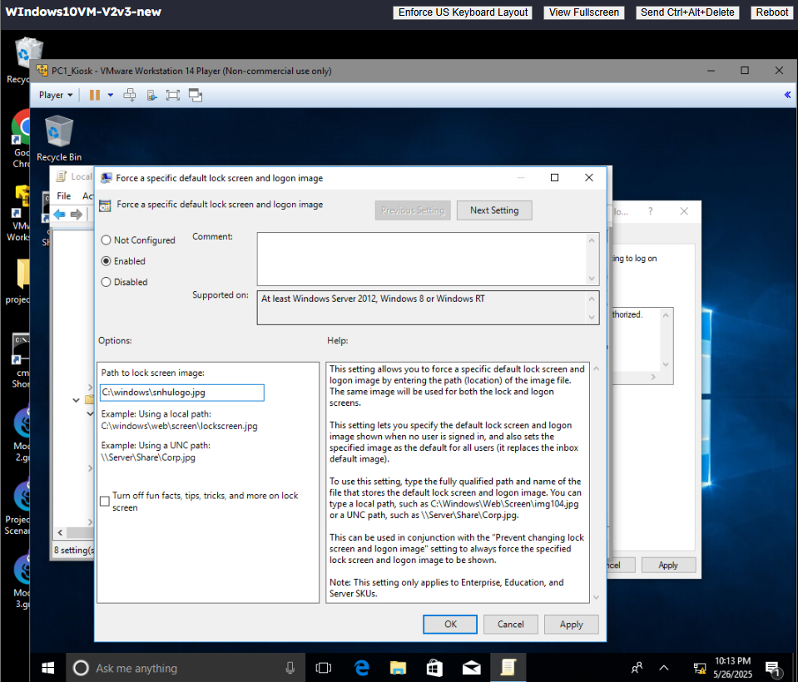

- Change default Windows firewall profile. | - Set Windows Defender Firewall Properties\Firewall State to on, and set Inbound connections and Outbound connections to allow.
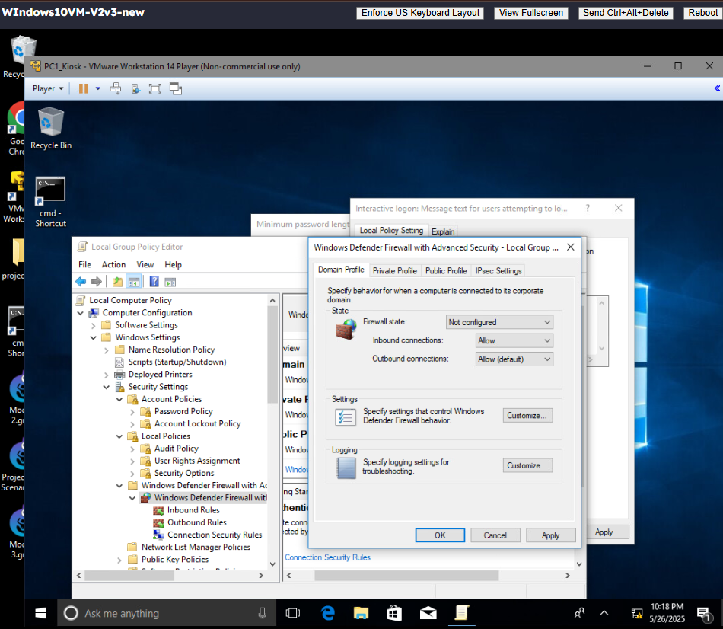

- Configure network resources to meet the network configuration settings as identified in the InfoSec Project One Activity. Provide a screenshot of each network setting configuration.

Network Router Setup
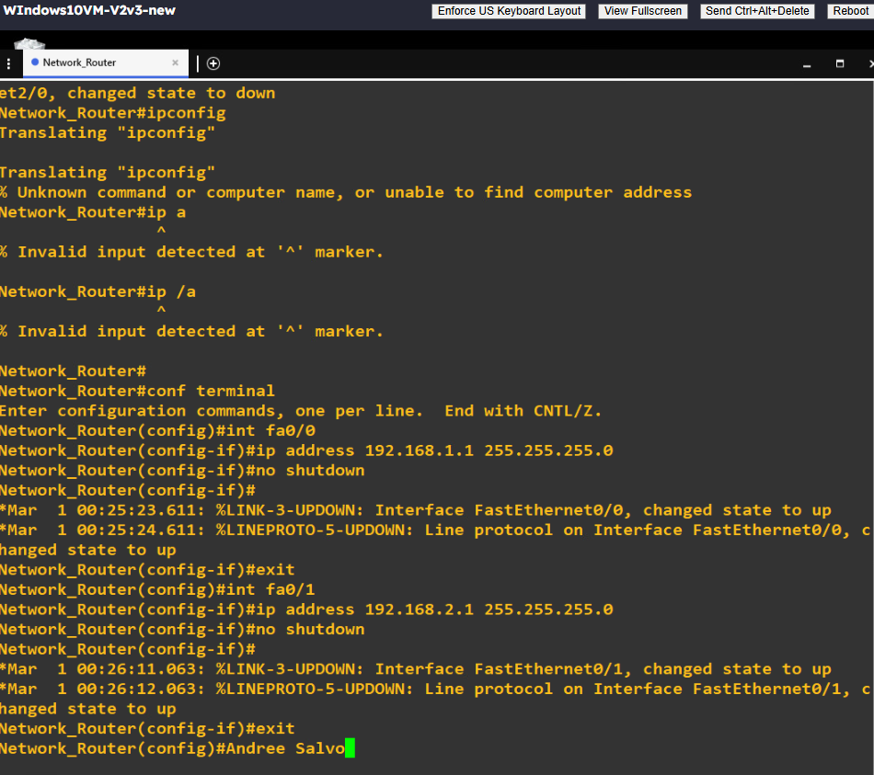

PC1_Kiosk Setup
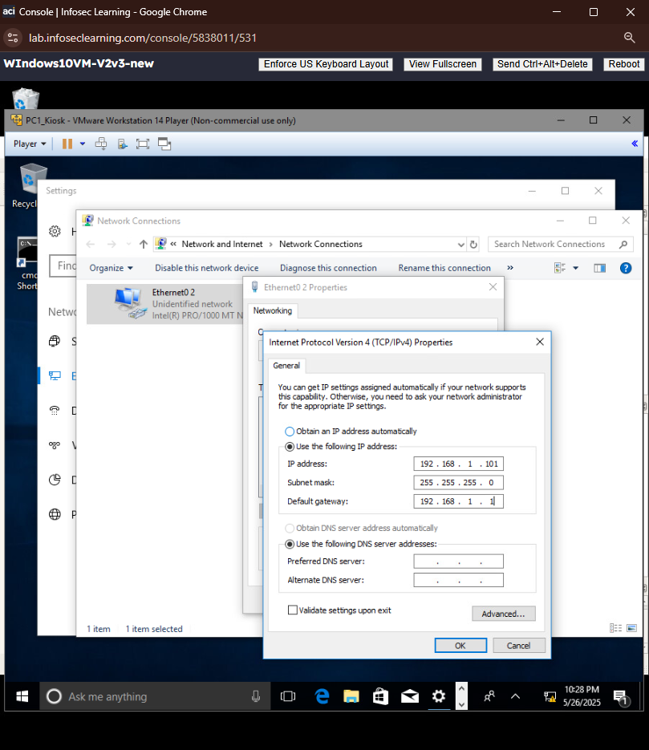

PC2_Kiosk Setup
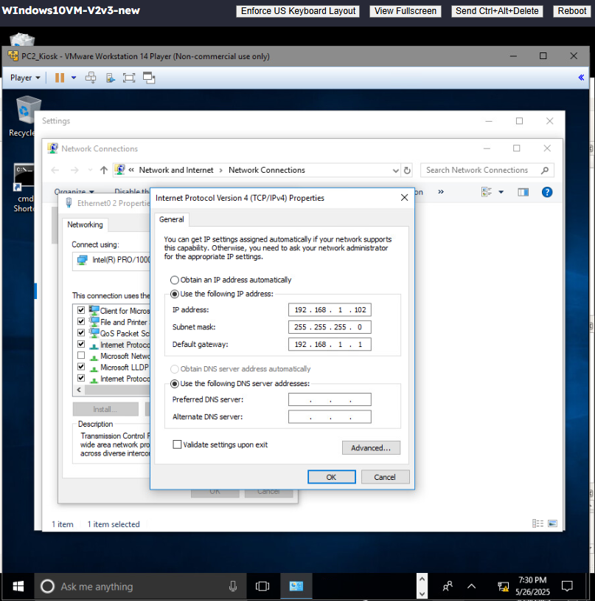

PC3_Kiosk Setup
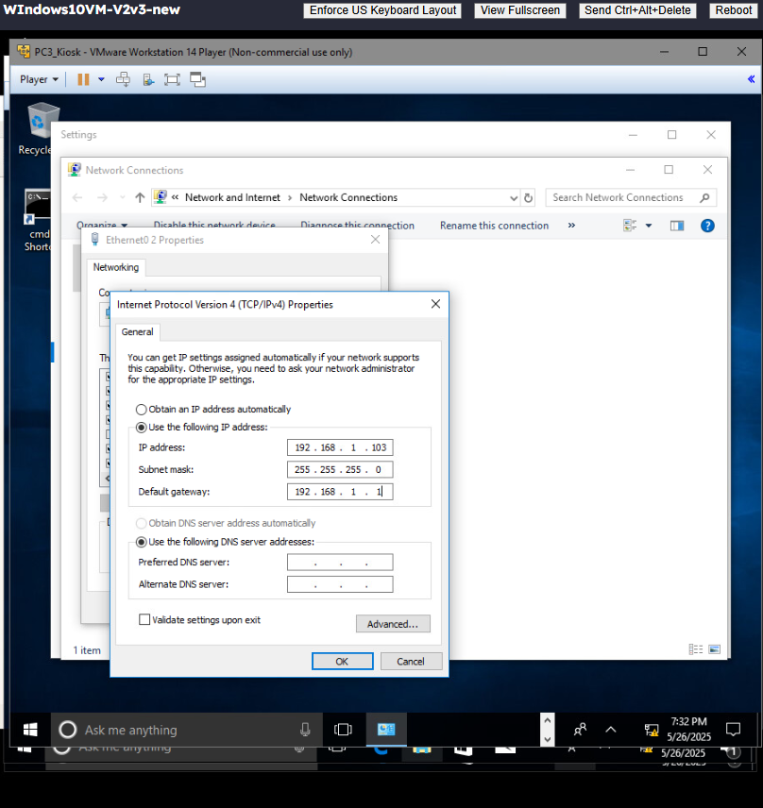

PC1_Admin Setup
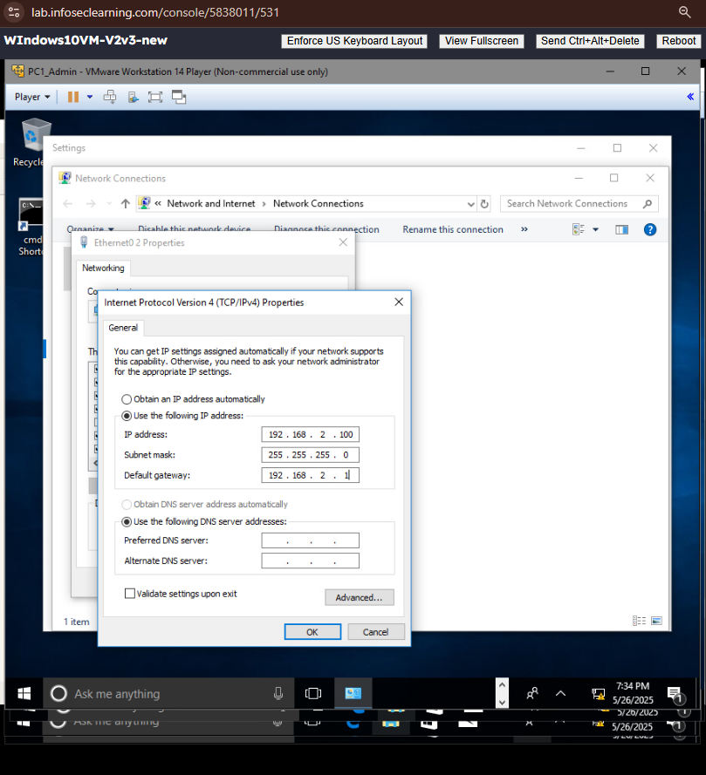

Server_Domain Setup
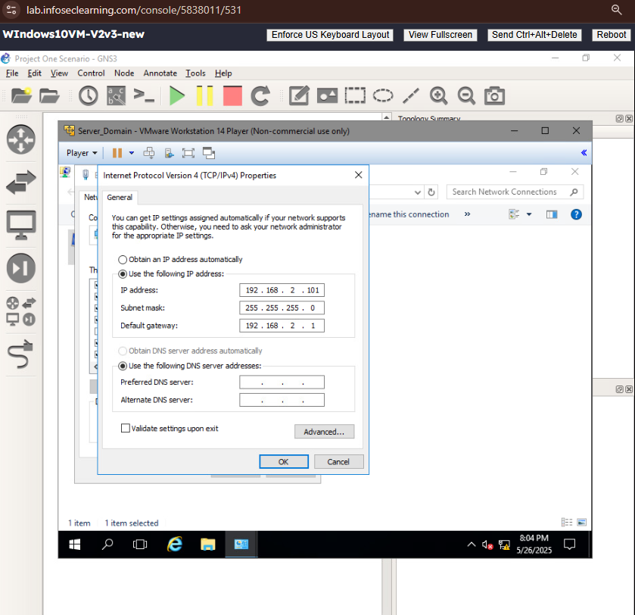
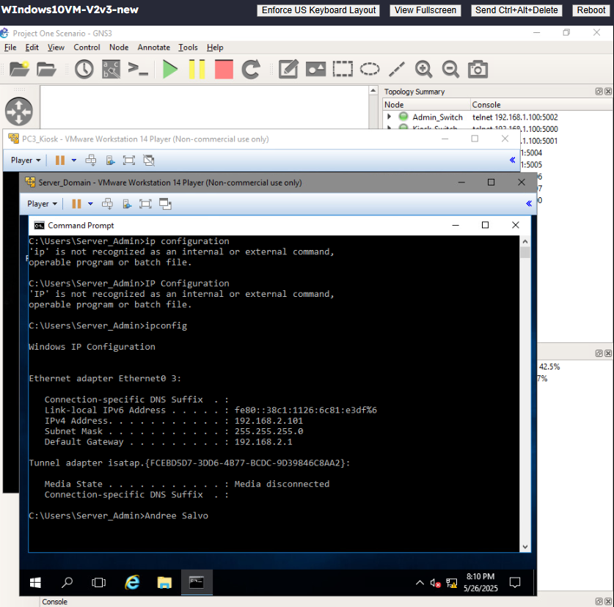

- Conceptual Justification for Uses of Virtual Systems
  - Describe the benefits of using virtualization technology in sandboxing.
Answer: Benefits of using a virtualization technology in sandboxing include things like enhanced security, which “isolates untrusted or potentially malicious code within a controlled environment that would prevent unauthorized users from gaining access to sensitive data” (Paubox, 2021), safe testing and development, improved stability where when you do use sandboxing it can help the systems stability by help preventing any failures.
  - Describe the drawbacks of using virtualization technology in sandboxing.
Answer: The Drawbacks that I personally encountered were Performance. When I was using virtualization, I remembered that I had multiple Virtual machines (VMs) running, and my computer started responding very slowly and lagging a little bit, but another drawback of using virtualization is vulnerabilities. If the virtualization isn’t properly installed, malware can exploit and escape inside the VM, causing it to become vulnerable to the entire system. And if the exploit does successfully escape, it can get inside your main host PC.
  - Describe a situation other than sandboxing where virtualization technology would be a valuable solution.
Answer: A situation besides sandboxing, where virtualization would be a valuable solution, would have to be a Virtual disaster recovery. A virtual disaster recovery is most efficient where organizations replicate VMs to another location, which keeps a live backup ready if something does go wrong. The benefits of using VDR are that “they are containerized into VMs, independent from the underlying hardware. An organization does not need the same physical servers at the primary site as at its secondary disaster recovery site.” (Crocetti, 2022)

References:
Paubox. (2021, October 12). Benefits of sandboxing. Retrieved from https://www.paubox.com/blog/benefits-of-sandboxing
Crocetti, P. (2022, December 16). Virtual disaster recovery. TechTarget. https://www.techtarget.com/searchdisasterrecovery/definition/virtual-disaster-recovery

